SECTION 1: Identification of the substance/mixture and of the company/undertaking
1.1. Product identifier
Product name SIMPLY GONE

1.2. Details of the supplier of the safety data sheet
Company CHAPMANDRAPER
Address CHAPMANDRAPER
Hatch, SANDY, Beds, SG19 1PS
Telephone 01767 699258
Email enquiries@simplygone.co.uk

SECTION 2: Hazards identification
2.1. Classification of the substance or mixture

Classification (CHIP): Xi: R36/38
Classification (CLP): Skin Corr. 1B: H314

Most important adverse effects:
Irritating to eyes and skin.

2.2. Label elements
Label elements under CLP (1272/2008):

Hazard statements: H315: Causes skin irritation.
H320: Causes eye irritation.
Signal words: Warning
Hazard pictograms: GHS07: Exclamation
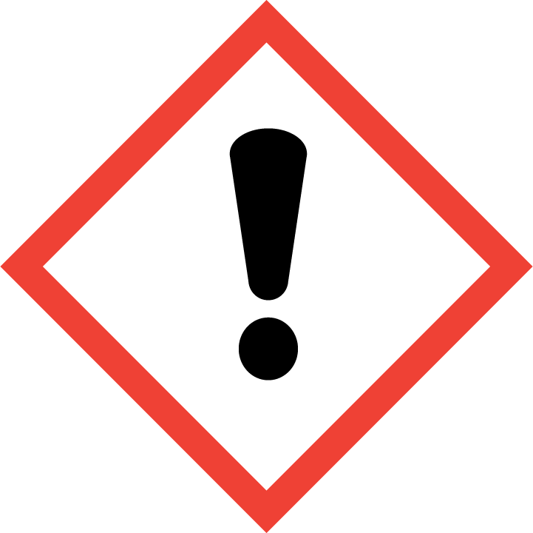

Precautionary statements:
P102: Keep out of reach of children
P264: Wash hands thoroughly after handling.
P280: Wear protective gloves / eye protection / face protection.
P301+312: IF SWALLOWED: Call a POISON CENTER or doctor/physician if you feel unwell.
P101: If medical advice is needed, have product container or label at hand.
P305+351+338: IF IN EYES: Rinse cautiously with water for several minutes. Remove contact lenses, if present and easy to do. Continue rinsing.
P233: Keep container tightly closed.
P234: Keep only in original container.

Label elements under CHIP (1999/45/ЕC):

Hazard symbols: Xi: Irritant.


Risk phrases: R36/38: Irritating to eyes and skin.

2.3. Other hazards
PBT: This product is not identified as a PBT substance.

SECTION 3: Composition/information on ingredients
3.2. Mixtures 67/548/EEC / 1999/45/EC

Chemical Name CAS No. Conc. (%w/w) Classification
Diakyldimethyl Ammonium Chloride 7173-51-5 1 – 10 % -: R10; Xn: R22; C: R34; -: R67

SECTION 4: First aid measures
4.1. Description of first aid measures
Inhalation May cause irritation to respiratory system. Move the exposed person to fresh air.
Seek medical attention if irritation or symptoms persist.
Eye contact Irritating to eyes. Rinse immediately with plenty of water for 15 minutes holding the eyelids open. Seek medical attention if irritation or symptoms persist.
Skin contact Causes burns. Wash off immediately with plenty of soap and water. Remove
contaminated clothing. Seek medical attention if irritation or symptoms persist.
Ingestion Ingestion may cause nausea and vomiting. May cause irritation to mucous membranes.
DO NOT INDUCE VOMITING. If swallowed, seek medical advice immediately and show this container or label.

SECTION 5: Firefighting measures
5.1. Extinguishing media Water spray, Alcohol resistant foam. Carbon dioxide (CO2). Dry powder.
Cool fire exposed containers with waterspray.
5.2. Special hazards arising from the substance or mixture
Burning produces irritating, toxic and obnoxious fumes.
5.3. Advice for firefighters
Wear protective equipment. Self-contained breathing apparatus.

SECTION 6: Accidental release measures
6.1. Personal precautions, protective equipment and emergency procedures
Avoid contact with the eyes and skin.
Ensure adequate ventilation of the working area.
Wear suitable protective equipment.
6.2. Environmental precautions
Do not allow product to enter drains or any water course. Prevent further spillage if safe.
Advise local authorities if large spills cannot be contained.
6.3. Methods and material for containment and cleaning up
Absorb with inert, absorbent material.
Transfer to suitable, labelled containers for disposal.

SECTION 7: Handling and storage
7.1. Precautions for safe handling
Avoid contact with eyes and skin. Use in a well-ventilated area.
7.2. Conditions for safe storage, including any incompatibilities
Keep out of the reach of children. Keep away from sources of ignition.
Store in cool, well ventilated area. Keep container tightly closed.

SECTION 8: Exposure controls/personal protection
8.2. Exposure controls
Respiratory protection Do not breathe dust/fume/gas/mist/vapour/spray.
Wear suitable respiratory equipment when necessary.
Hand protection Chemical resistant gloves (PVC).
Eye protection Avoid contact with eyes. In case of splashing, wear eye protection.
Protective equipment Avoid contact with eyes and skin.
Immediately remove all soiled and contaminated clothing.
Wash all contaminated clothing before reuse.

SECTION 9: Physical and chemical properties
9.1. Information on basic physical and chemical properties
State Liquid
Colour Yellow
Odour Characteristic
Relative density 1.000 (Water = 1.000 @ 20 °C)
Flash point n/a
Solubility Miscible in water

SECTION 10: Stability and reactivity
10.2. Chemical stability
Stable under normal conditions.
10.5. Materials to avoid
Oxidising agents. Strong acids and strong bases.
10.6. Hazardous decomposition products
Burning produces irritating, toxic and obnoxious fumes.

SECTION 11: Toxicological information
11.1. Information on toxicological effects
Skin corrosion/irritation
May cause irritation to eyes.
Seek medical attention if irritation or symptoms persist.

SECTION 12: Ecological information
Persistence and degradability
The product is readily biodegradable.
Additional ecological information
Do not allow product to reach ground water, water course or sewage system.
The product contains materials that are harmful to the environment.
Further information
No further relevant information available.

SECTION 13: Disposal considerations
General information
Do not allow product to enter drains.
Disposal methods
The user's attention is drawn to the possible existence of regional or national
regulations regarding disposal.

14. TRANSPORT INFORMATION

Transport class: This product does not require a classification for transport.

15. REGULATORY INFORMATION
Safety, health and environmental regulations/legislation specific for the substance or mixture
Labelling according to Regulation (EC) No 1272/2008
This safety data sheet is in compliance with the Regulation (EC) N° 1907/2006
Chemical safety assessment:
A Chemical Safety Assessment has not been carried out.
Other data
The surfactant(s) contained in this preparation complies(comply) with the biodegradability criteria as laid down in Regulation (EC) N° 648/2004 on detergents. Data to support this assertion are held at the disposal of the competent authorities of the Member States and will be made available to them at their direct request or at the request of a detergent manufacturer.

16. OTHER INFORMATION
Revision: This document differs from the previous version in the following areas:.
2 - 2.2. Label elements - Label elements under CLP (1272/2008):

Text of risk phrases in Section 2 & 3.
H315: Causes skin irritation.
H320: Causes eye irritation.
R10: Flammable.
R22: Harmful if swallowed.
R34: Causes burns.
R36/38: Irritating to eyes and skin.
R67: Vapours may cause drowsiness and dizziness.

Further information The information supplied in this Safety Data Sheet is designed only as guidance for the safe use, storage and handling of the product. This information is correct to the best of our knowledge and belief at the date of publication however no guarantee is made to its accuracy. This information relates only to the specific material designated and may not be valid for such material used in combination with any other materials or in any other process.

